Smt. Motadevi T. T. College Mahwa
B.Ed. Staff detail
S.No. | NAME | FATHER NAME | DOB | POST & SERVICE | Last Qualification | PAY SKILL | PHOTO
1 | DR. VIJAY SINGH JAT | SUWA RAM JAT | 21/06/1966 | PRINCIPAL | M.Sc. / Ph.D | 28000 | 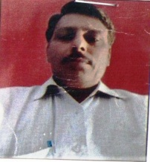
2 | AJAY SINGH RAJPOOT | KAMLESH SINGH RAJPOOT | 8/8/1986 | LECTURER | M.A. / M.Ed. | 18000 | 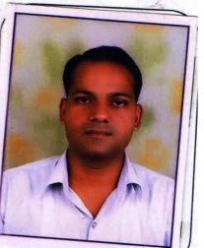
3 | SWEETY SAHU | KISHAN LAL SAHU | 17/01/1991 | LECTURER | M.A. / M.Ed. | 18000 | 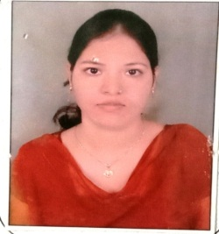
4 | IMRAN HUSSAIN | AHMED HUSSAIN | 4/7/1992 | LECTURER | M.A./ M.Ed. | 18000 | 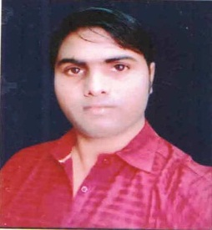
5 | MURARI LAL YADAV | HEERA LAL YADAV | 5/9/1988 | LECTURER | M.Sc. / M.Ed. | 9500 | 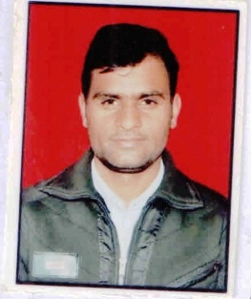
6 | MAYA BHATT | SURESH BHATT | 3/3/1984 | LECTURER | M.A. / M.Ed. | 9000 | 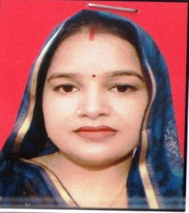
7 | DEVENDRA SINGH | KEHARI SINGH | 22/10/1981 | LECTURER | M.A. / M.Ed. | 18000 | 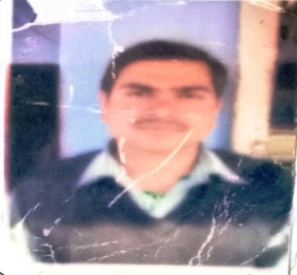
8 | SHYAM SINGH GURJAR | HARGYAN SINGH GURJAR | 4/3/1989 | LECTURER | M.A. / M.Ed. | 9000 | 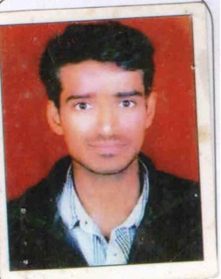
9 | DRUGA DEVI RAJPUT | BAJRANG SINGH | 10/4/1987 | LECTURER | M.A. / M.Ed. | 9500 | 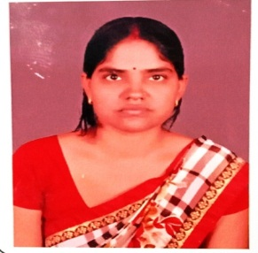
10 | BIRENDRA SINGH | SORAN SINGH | 1/6/1966 | LECTURER | M.A. / M.Ed. | 18000 | 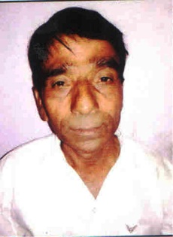
11 | NARENDRA KUMAR SHARMA | BHAG CHAND SHARMA | 8/7/1983 | LECTURER | M.A. / M.Ed. | 18000 | 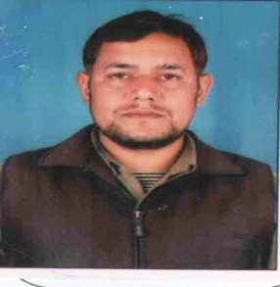
12 | BRIJESH KUMAR SHARMA | GANGA SAHAY SHARMA | 20/02/1977 | LECTURER | M.A. / M.Ed. | 18000 | 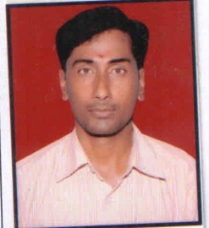
13 | RAJENDRA SINGH GURJAR | RAJARAM GURJAR | 10/7/1980 | LECTURER | M.A. / M.Ed. | 18000 | 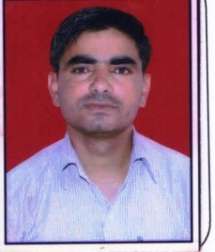
14 | PUSHPALATA | VIRENDRA SINGH | 25/06/1983 | LECTURER | M.A. / M.Ed. | 18000 | 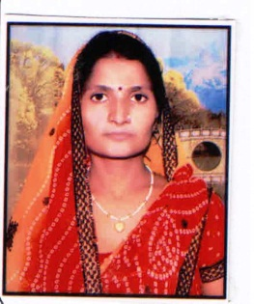
15 | MOHAN LAL SHARMA | PRABHU DAYAL SHARMA | 4/3/1965 | LECTURER | M.A. / M.Ed. | 18000 | 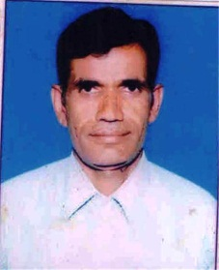
16 | VANDANA GUPTA | NARESH KUMAR | 1/3/1992 | LECTURER | M.Sc. / M.Ed. | 16500 | 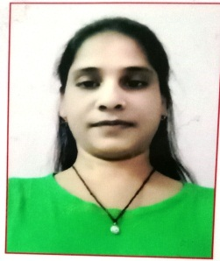
17 | MANVENDRA SHARMA | YOGENDRA KUMAR SHARMA | 10/4/1988 | PTI | MPED | 10000 | 